

# ***Working Title***

***High Level Design (HLD)***

# *CSC.154.0001 - Group 4*

*Eric Perry*

*Eric Hodge*

*Oras Alhammadi*

*George Saad*

*Steven Torres*

*February 15, 2019*

*Version 1.0*



**Revisions**

|  |  |  |  |
| --- | --- | --- | --- |
| **Version** | **Primary**  **Author(s)** | **Description of Version** | **Date Completed** |
| 1st Draft | Eric Perry  Eric Hodge  Steven Torres  Oras Alhammadi  George Saad | Initial Draft of HLD Doc for Working Title (Group 4’s Project – Spring 2019) | 02/22/19 |

**Review & Approval**

**Requirements Document Approval History**





**Table of Contents**

**Working Title** 1

CSC.154.0001 - Group 4 1

1. General Description 4

1.1 Introduction 4

1.2 Scope of this Document 4

1.3 Overview 4

1.4 Division of Responsibilities 4

2. Architecture 5

3. Security 5

4. Hardware 5

5. User Interface 5

6. External Interface 5

7. Reports 5

8. Database 5

9. UML Diagrams 6

9.1 Use Case Diagram 6

9.2 Database UI Interaction Diagram 7

9.3 Application Database Interaction Diagram 8

9.4 Activity Diagram 9

9.5 Database Structure Diagram 9

9.6 Suggested WaitStaff Class Diagram 10

## **1. General Description**

### **1.1 Introduction**

The document is a high level design overview for (Working Title) App, an application for tracking and managing an ingredients inventory for food industry clients.

### **1.2 Scope of this Document**

The scope of this document will cover the structure of the program, architecture, data persistence and flow, user work flow, and hardware requirements.

### **1.3 Overview**

*(Working Title)* is an inventory management and tracking application that utilizes a relational database. The system stores an inventory of individual ingredients as well as tables of menu items linked to those ingredients. Users will be able to update, in real time, inventory quantities while processing orders from front house to back house. Wait staff and cooks will be notified if an order cannot be completed due to inventory shortage. Managers will be able to view ingredient and menu item history, to include frequency of use/order by period of time, as well as place orders with vendors online or print out an purchase inventory. Market prices for ingredients will also be available through third party integration of APIs/EPIs.

### **1.4 Division of Responsibilities**

The following responsibilities have been assigned to group members:

Eric Perry – Project Manager, Front-end to Back-end Integration

Eric Hodge – Project Manager, Back-end to Database Integration

Steven Torres – Front-end design

Oras Alhammadi – Back-end design

Geroge Saad – Database design

## **2. Architecture**

The (Working Title) app will utilize a Two-Tier Client/Server architecture to allow multiple work stations connected to a single database. The software will utilize the Model-View-Controller (MVC) architecture pattern. By utilizing MVC, the user’s computer will control data flow, presentation, and computation, freeing up the database from the responsibilities of computational processing.

## **3. Security**

The (Working Title) app will allow for individual user accounts with password. Different levels of user accounts will dictate what application views are available to the user. The application will utilize UTF-8 encoded hash and salt implemented with Py-bcrypt.

## **4. Hardware**

The (Working Title) app will be designed to run on work stations conforming to the Object Linking & Embedding for Retail Point of Sale (OPOS) Standard as developed for Microsoft Windows based systems as well as standard Windows based PCs.

## **5. User Interface**

The server account user interface will offer touchscreen capability to work with common OPOS work stations and is coded with standard HTML5/CSS/JS as a single page application.

The manager account user interface will be served as a web based application, offering the ability to open new sections within their own tab.

For the users (front end employees) the (working tittle) app uses an interface with pictures of the different menu items separate by groups, (entrees, main dishes, soups), each time that a menu item is selected the app is going to ask if they want to change some item or special instructiona for the order an make a request to the database if the item is available, after the order is taked the app is going ask the user to give the confirmation if the order is correct, when the order is confirmed the POS is going to send the order to the kitchen.



## **6. External Interface**

The (Working Title) app will interface with external API/EPIs such as The Farmer’s Market API to assist with online ordering of ingredients and real time market pricing.

## **7. Reports**

The (Working Title) app will create reports through web based application views. Reports will allow for aggregation of historical pricing and use of ingredients and dishes in a customizable time period. Additionally, reports for current inventory, inventory to order, and inventory on order will be available.

## **8. Database**

The (Working Title) app will utilize a MySQL database for storage and retrieval of inventory, inventory quantities, menu items, archived reports, and managerial notes.

## **9. UML Diagrams**

### **9.1 Use Case Diagram**

1. 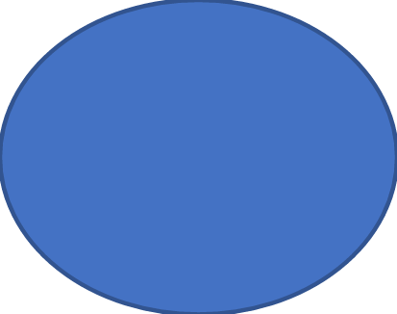







### **9.2 Database UI Interaction Diagram**

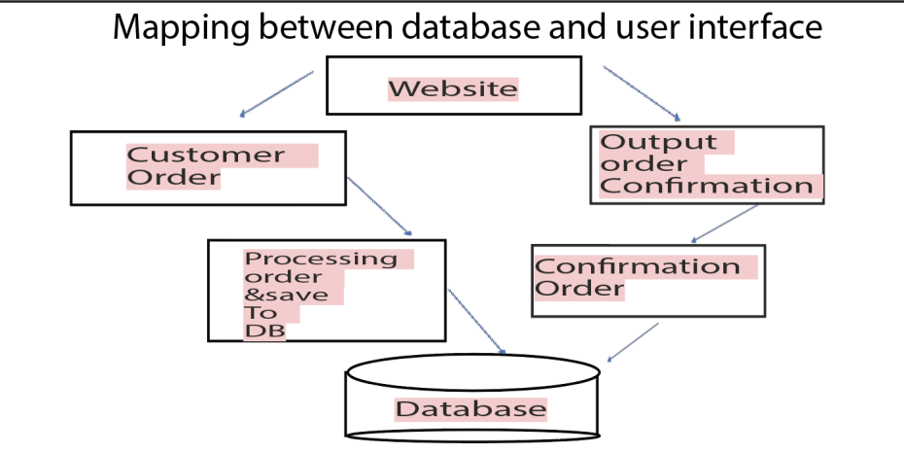

### **9.3 Application Database Interaction Diagram**

|  |
| --- |
| Execution Environment Execution Environment  Python MySQL |



### **9.4 Activity Diagram**

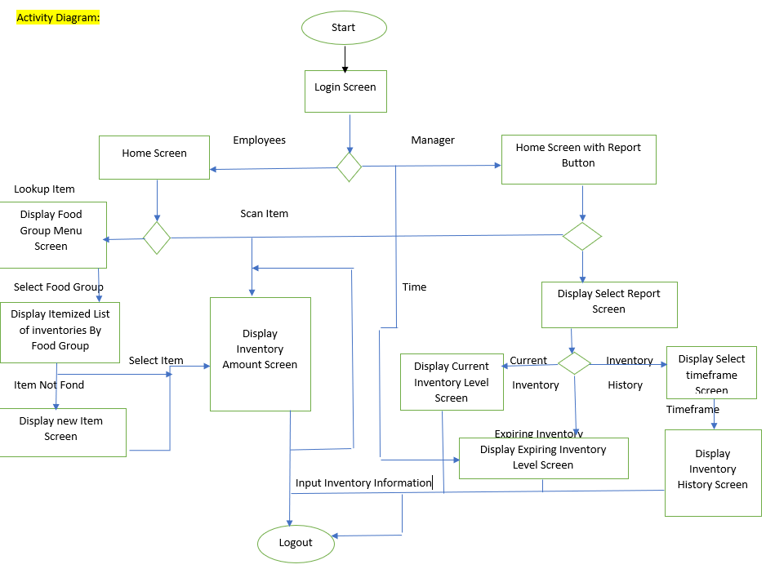

### **9.5 Database Structure Diagram**

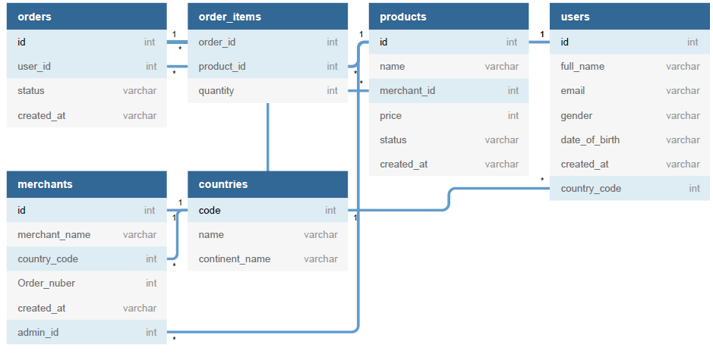

### **9.6 Suggested WaitStaff Class Diagram**

Show below is the suggest flow and classes utilized in a WaitStaff transaction.

